**Assignment – Power BI Installation**

1. **Install Power BI Desktop and share the final screenshot of the report view page which appears when power desktop starts.**

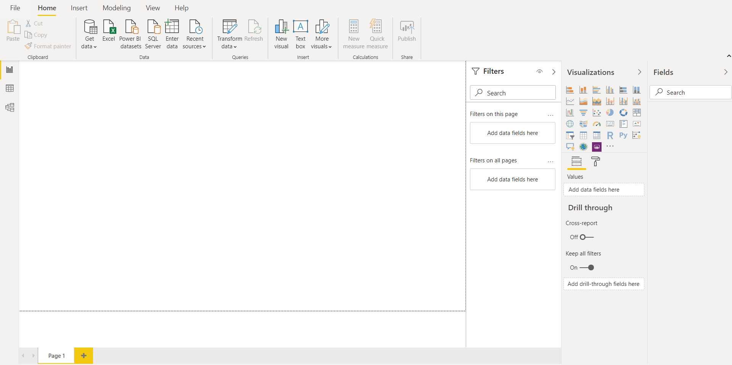

1. **Prepare a document and with the following screenshot − Report View − Data View − Model View − Power Query Editor − Advance Editor**

Report View:



Data View:

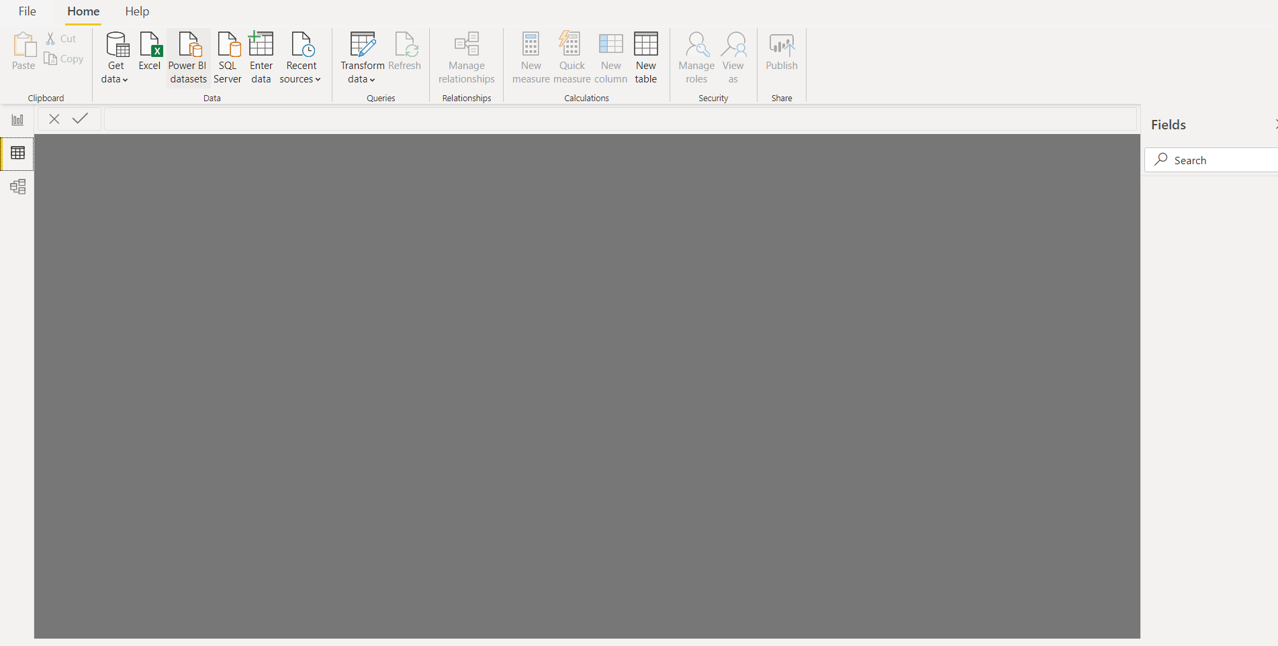

Model View:

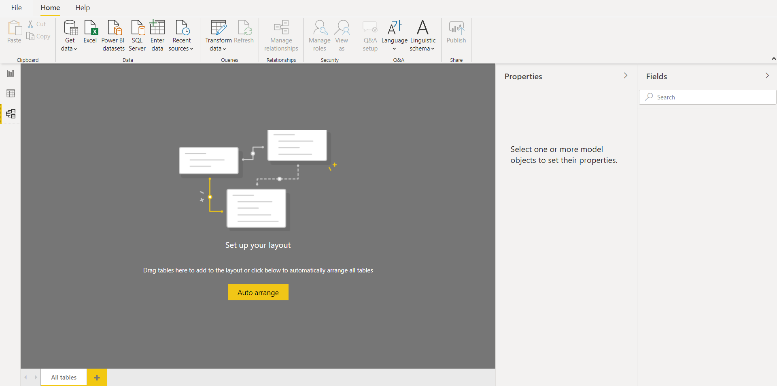

Power Query Editor:

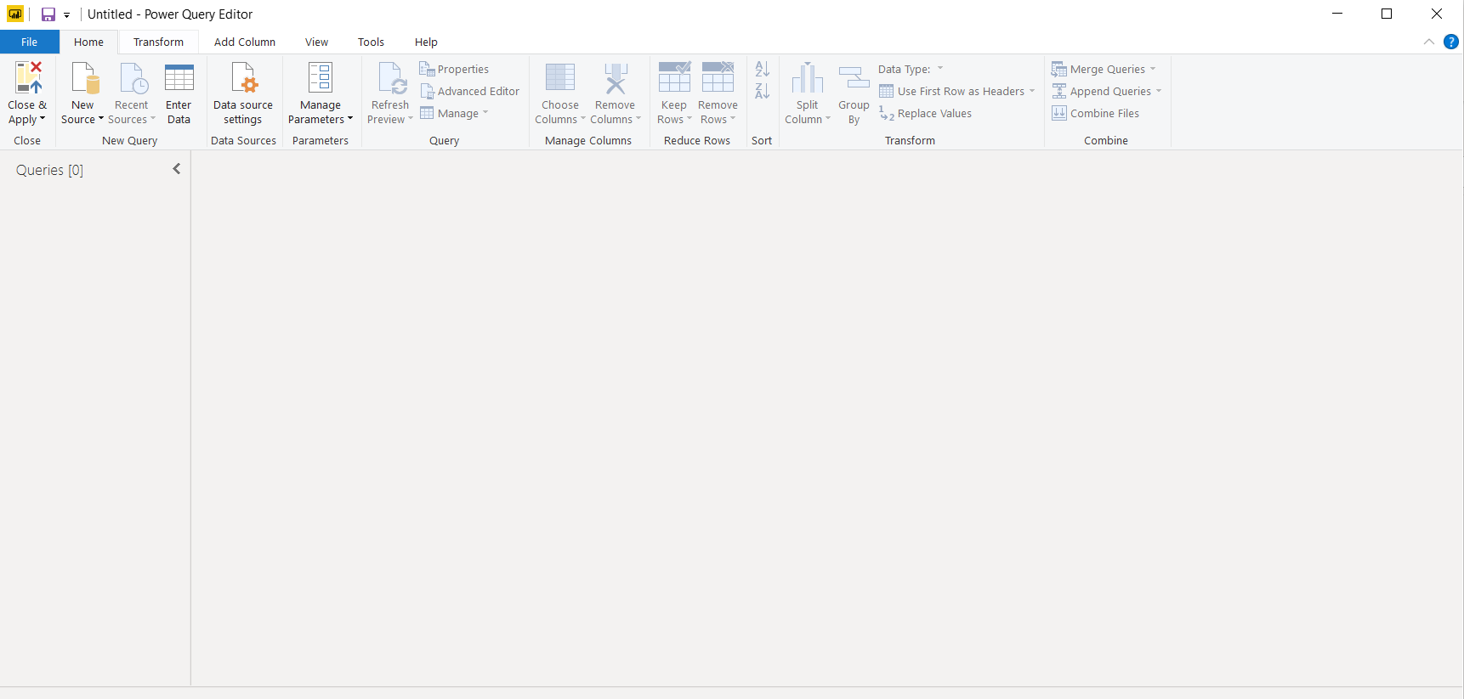

Advanced Editor:

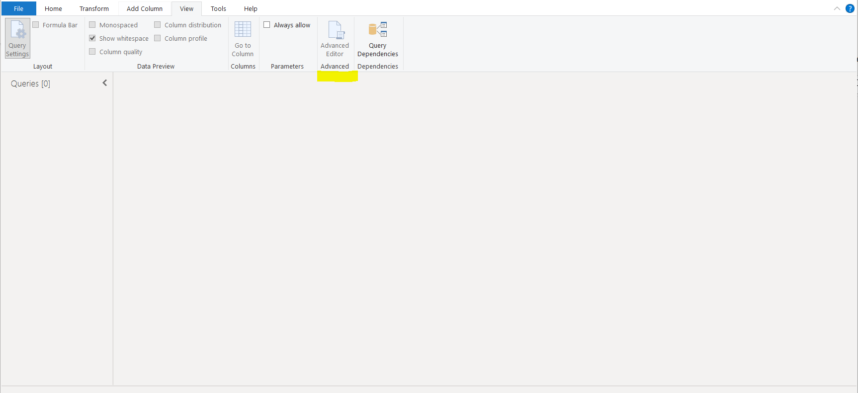

1. **Prepare a document with details of the following along with their price**

**− Power BI Desktop − Power BI Pro − Power BI Premium**

## Power BI Desktop

Price - **Free**

This free version is surprisingly functional. It allows you to connect to hundreds of data sources (no limit/restriction other than the amount of data you pull in), clean and prepare your data, and build visualizations (no limit). All of the types of visualization options in Power BI Pro are available in Power BI Desktop.

Power BI Desktop is quite functional, but there are limits on data refreshes, sharing (**You can neither share with others nor consume shared content with Power BI Desktop**), and data storage.

## Power BI Pro

Price - **$9.99** Monthly price per user

### **On-Premise Data Gateways**

If your data resides On-Premise (not somewhere in the cloud), you can now connect to this data and analyze it. A common example of this is a self-hosted SQL database.

### **More Data Storage**

Power BI Pro allows you up to 10 GB per Power BI Pro License. The free version caps you at 1GB per user.

### **Better Data Refreshes**

In Power BI Pro, you can better schedule data refreshes so that your team always has the latest version of your data.

### **Sharing and Collaboration**

The key feature here: If you want to share data, reports, and dashboards privately – you need to look at Power BI Pro. It allows you to share your data with individual coworkers, or publish enterprise-wide “content packs” and “apps” with row-level data security**.  Everyone that you want to share content with must be assigned a Power BI Pro license.**

## Power BI Premium

Price - **$4,995** Monthly price per dedicated cloud compute and storage resource with annual subscription

### **Separate Resources**

No more “noisy neighbours”. Power BI Premium gives you your own processing environment, so your Power BI operations can’t be slowed down by other users that aren’t even within your company.

### **More Storage**

Your company gets up to 100 TB of data storage to share in Power BI Premium.

### **Larger Datasets**

Power BI Premium allows you to work with datasets up to 50 GB in size.

### **Free User Sharing Access**

If you use Power BI Premium, then free users are able to consume shared dashboards.